Rectangle–Circular Open Shapes
# Source: AI Source: Provided by: [Data Path: Persons Table -> ID Column: 1, Name_En Column: Motasem Essam] -> From: [ChatGPT] on [7/25/2026]
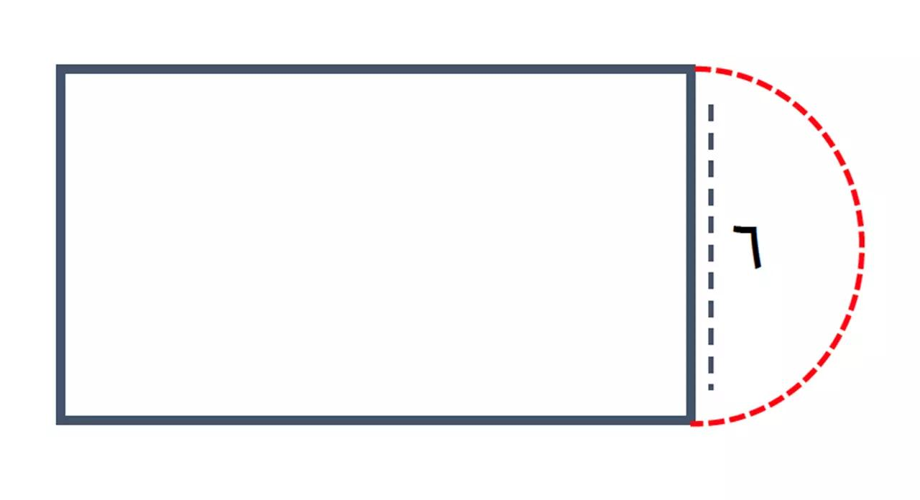
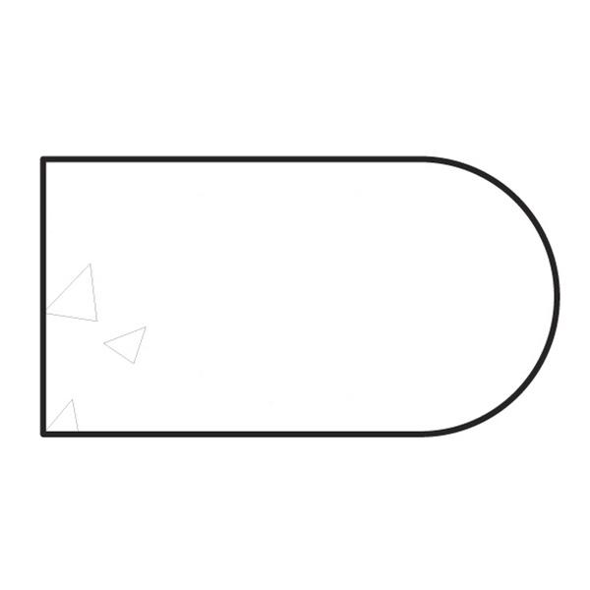
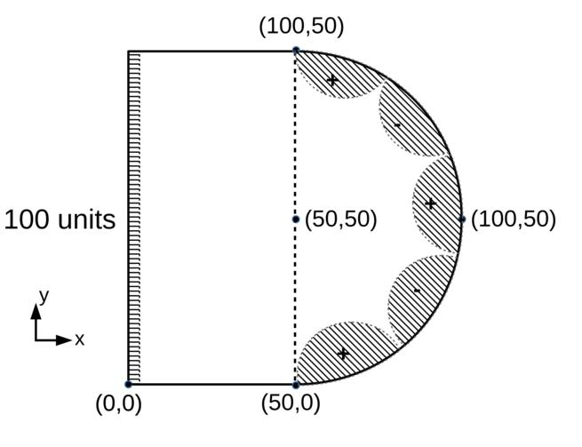
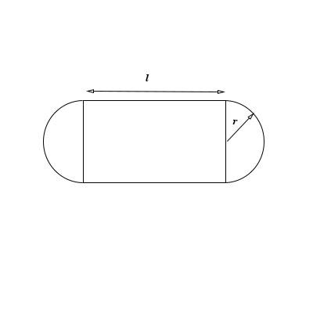
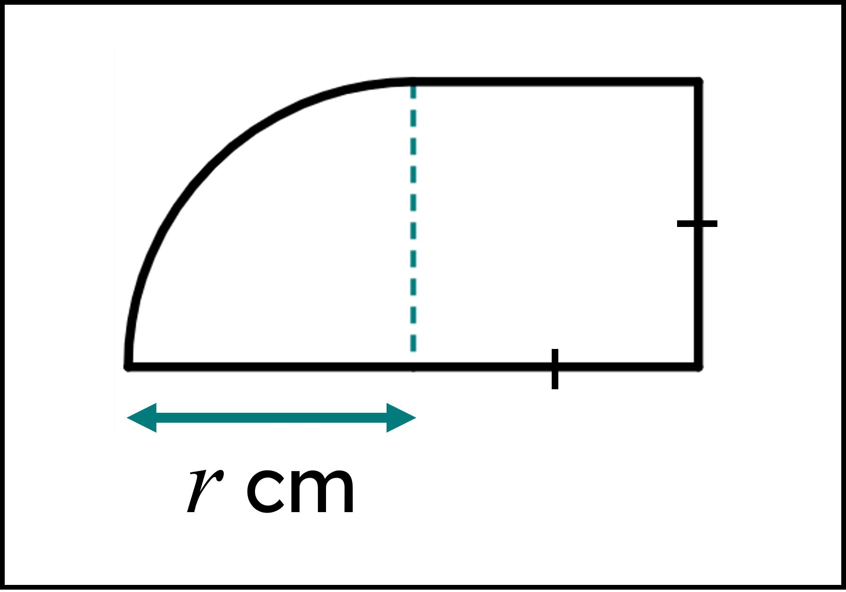

Definition
# Source: AI Source: Provided by: [Data Path: Persons Table -> ID Column: 1, Name_En Column: Motasem Essam] -> From: [ChatGPT] on [7/25/2026]
A Rectangle–Circular Open Shape is an open mixed shape that combines horizontal and vertical rectangular segments with one or more circular arcs.
$$\boxed{\text{Rectangle–Circular Open Shape}=\text{Rectangular Segments}+\text{Circular Arc(s)}+\text{Open Boundary}}$$
The shape is open because its boundary does not completely connect to form a closed region.

Characteristics
# Source: AI Source: Provided by: [Data Path: Persons Table -> ID Column: 1, Name_En Column: Motasem Essam] -> From: [ChatGPT] on [7/25/2026]
A Rectangle–Circular Open Shape:
- Is open.
- Contains horizontal and/or vertical straight segments.
- Contains at least one circular arc.
- Combines rectilinear and curved geometry.
- Has two or more endpoints.
- May contain right-angle corners.
- May contain smooth transitions between straight segments and arcs.
- Does not enclose an area by itself.
- Can be regular-looking or irregular.
- Can be symmetric or asymmetric.

Types of Rectangle–Circular Open Shapes

1. Single-Arc Rectangle Open Shape
# Source: AI Source: Provided by: [Data Path: Persons Table -> ID Column: 1, Name_En Column: Motasem Essam] -> From: [ChatGPT] on [7/25/2026]
A rectangular open path containing one circular arc.
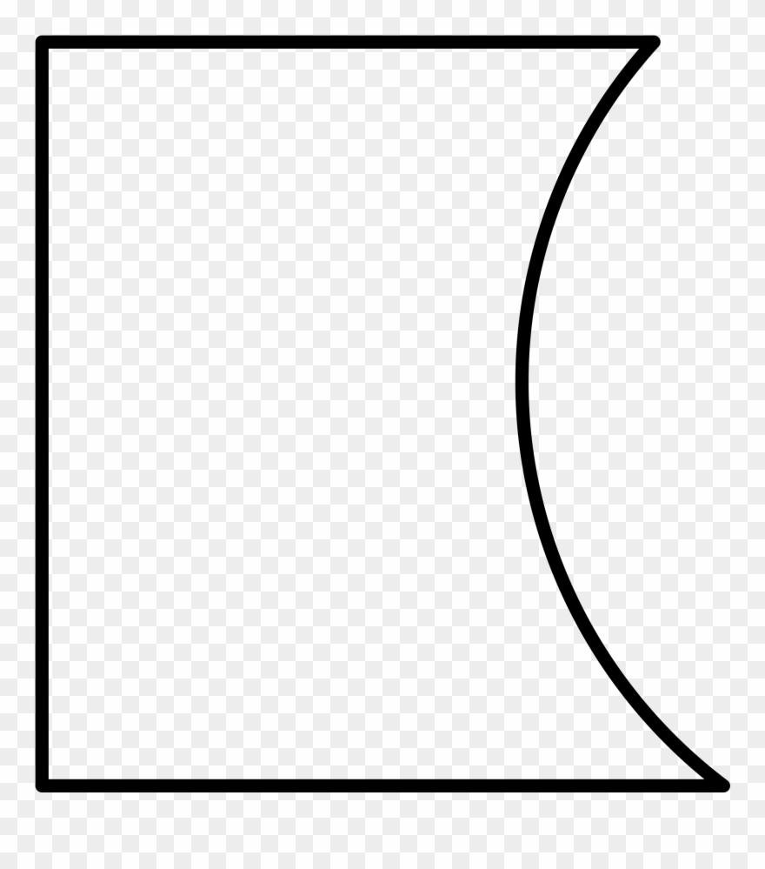
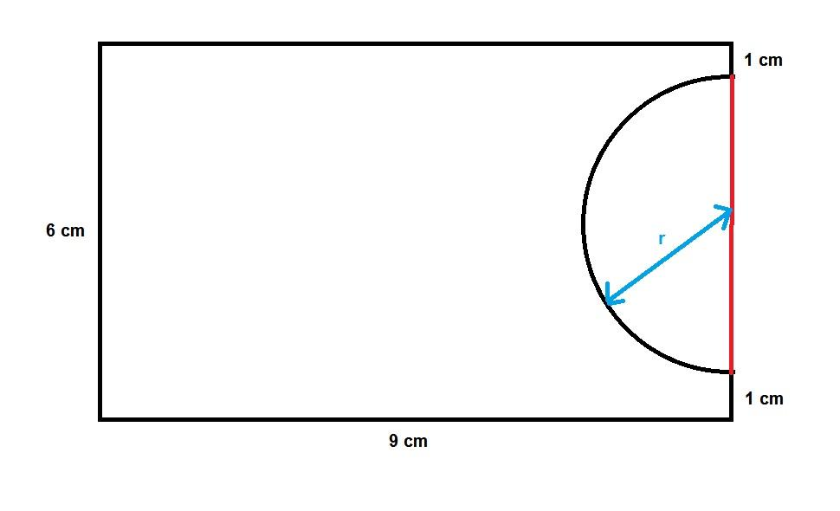
This is one of the simplest rectangle–circular combinations.

2. Multi-Arc Rectangle Open Shape
# Source: AI Source: Provided by: [Data Path: Persons Table -> ID Column: 1, Name_En Column: Motasem Essam] -> From: [ChatGPT] on [7/25/2026]
A rectangular path containing multiple circular arcs.
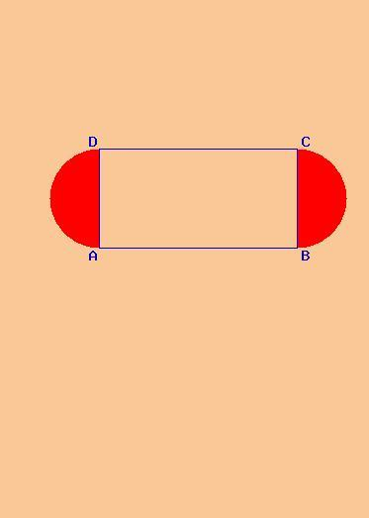
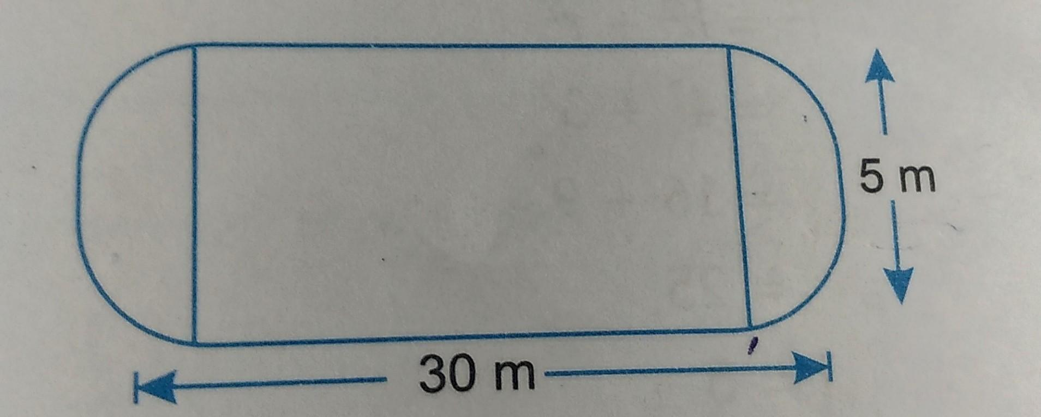
The arcs may have equal or different radii.

3. Rounded-Corner Rectangle Open Shape
# Source: AI Source: Provided by: [Data Path: Persons Table -> ID Column: 1, Name_En Column: Motasem Essam] -> From: [ChatGPT] on [7/25/2026]
An open rectangular path in which one or more corners are replaced by circular arcs.
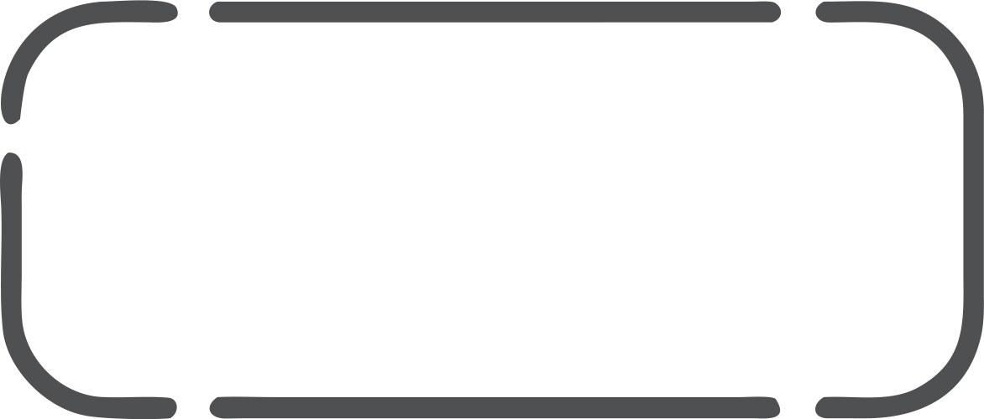
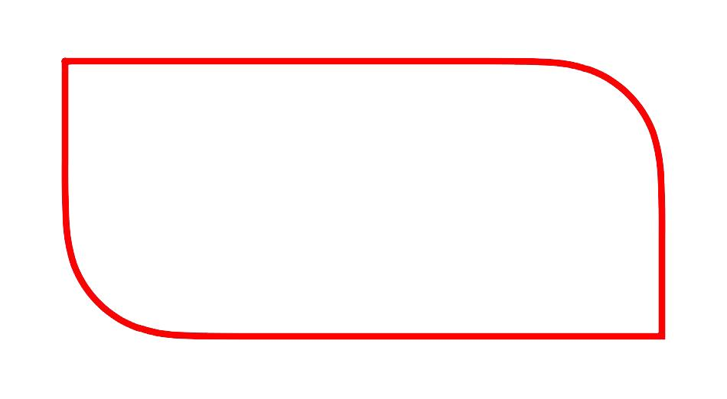
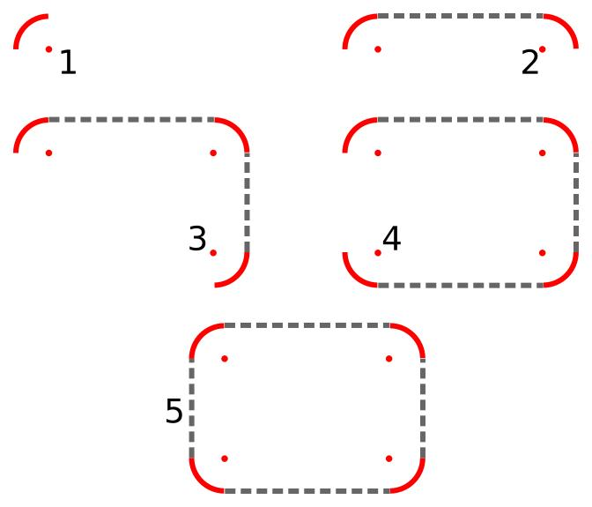
The curved portions replace sharp (90^\circ) corners.

4. Semicircular-Ended Rectangle Open Shape
# Source: AI Source: Provided by: [Data Path: Persons Table -> ID Column: 1, Name_En Column: Motasem Essam] -> From: [ChatGPT] on [7/25/2026]
A rectangular path with a semicircular or approximately semicircular section at one end.
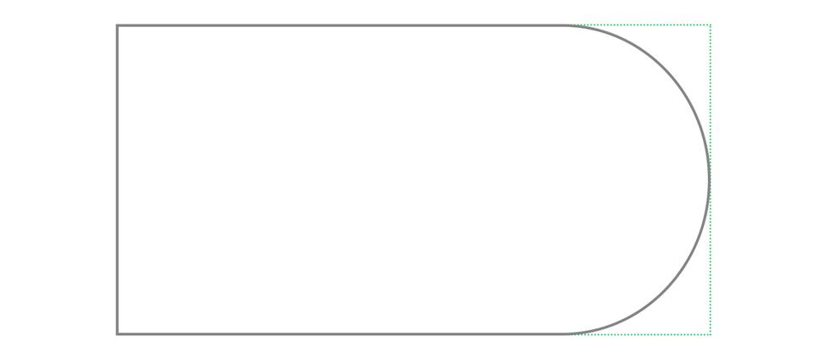
The circular portion contributes curved geometry while the remaining portions are rectilinear.

5. Tangential Rectangle–Circular Open Shape
# Source: AI Source: Provided by: [Data Path: Persons Table -> ID Column: 1, Name_En Column: Motasem Essam] -> From: [ChatGPT] on [7/25/2026]
A straight rectangular segment connects smoothly to a circular arc at a tangent point.
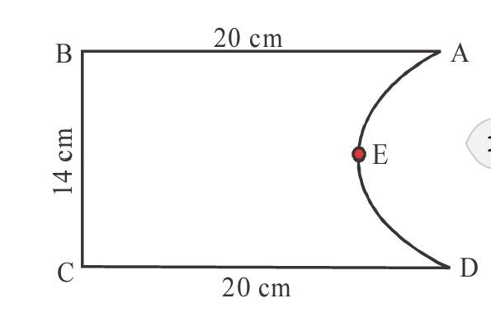
At the joining point, the straight segment and circular arc can share the same tangent direction.

6. Cornered Rectangle–Circular Open Shape
# Source: AI Source: Provided by: [Data Path: Persons Table -> ID Column: 1, Name_En Column: Motasem Essam] -> From: [ChatGPT] on [7/25/2026]
A circular arc meets a rectangular segment at a visible corner rather than a smooth tangent transition.
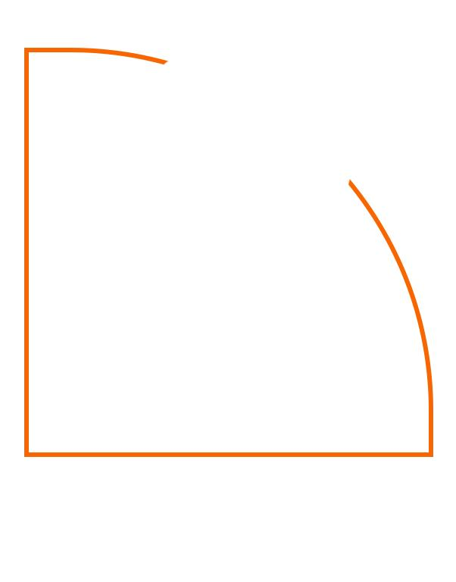
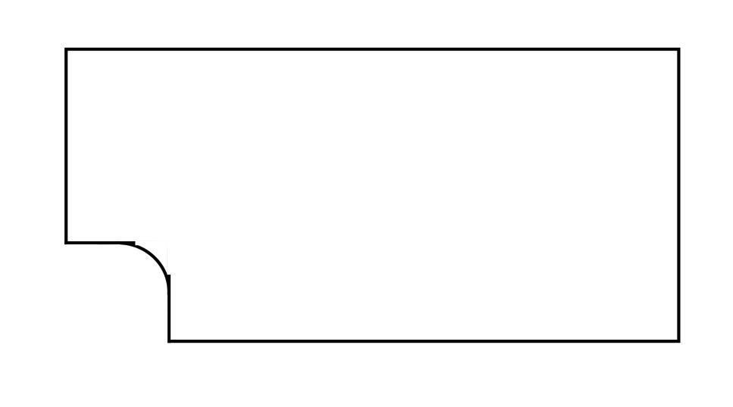
The direction changes abruptly at the junction.

7. Symmetric Rectangle–Circular Open Shape
# Source: AI Source: Provided by: [Data Path: Persons Table -> ID Column: 1, Name_En Column: Motasem Essam] -> From: [ChatGPT] on [7/25/2026]
The rectangular segments and circular arcs are arranged symmetrically.
The symmetry may be horizontal, vertical, or another recognizable reflection.

8. Asymmetric Rectangle–Circular Open Shape
# Source: AI Source: Provided by: [Data Path: Persons Table -> ID Column: 1, Name_En Column: Motasem Essam] -> From: [ChatGPT] on [7/25/2026]
The rectangular segments and circular arcs have unequal positions, lengths, or radii.
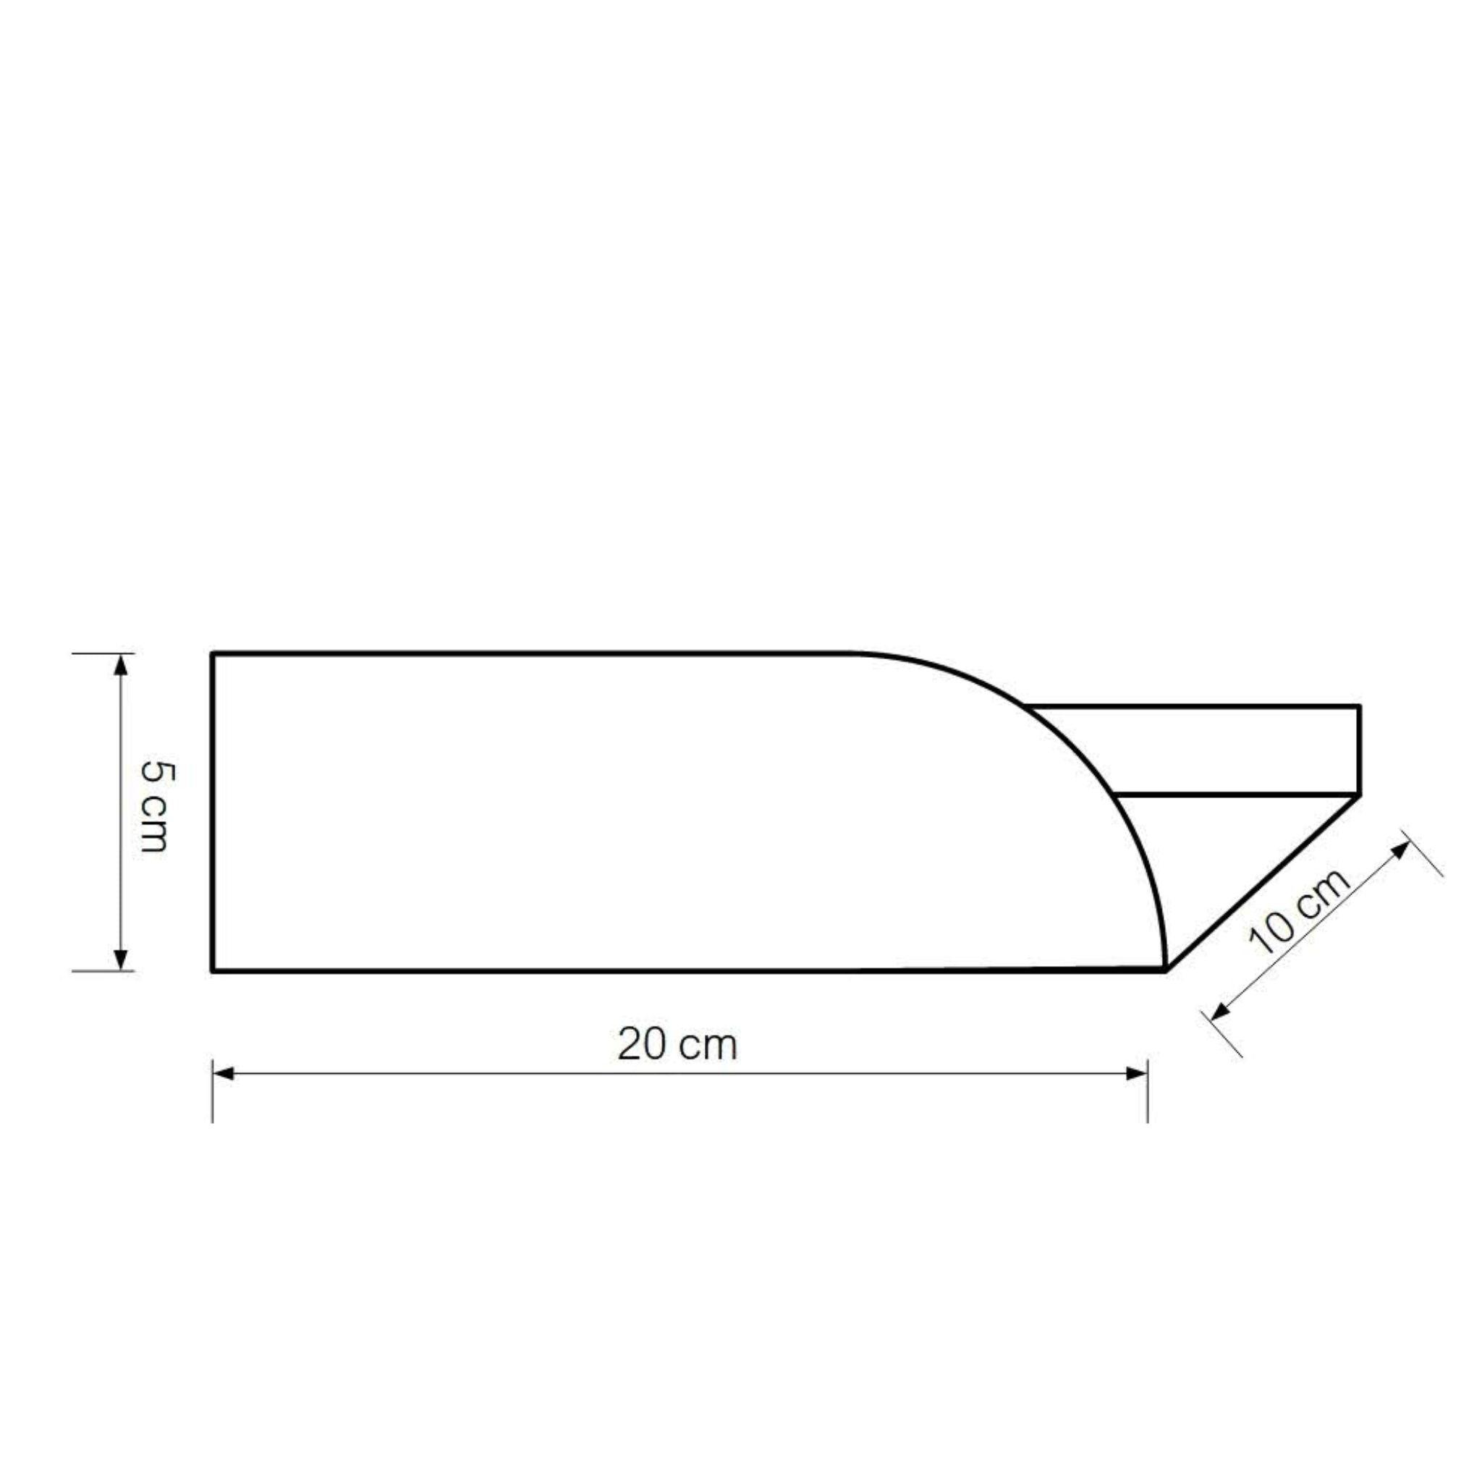
This is useful when classifying irregular mixed shapes.

9. Wavy Rectangle–Circular Open Shape
# Source: AI Source: Provided by: [Data Path: Persons Table -> ID Column: 1, Name_En Column: Motasem Essam] -> From: [ChatGPT] on [7/25/2026]
Several rectangular segments and circular arcs are arranged in a wave-like path.
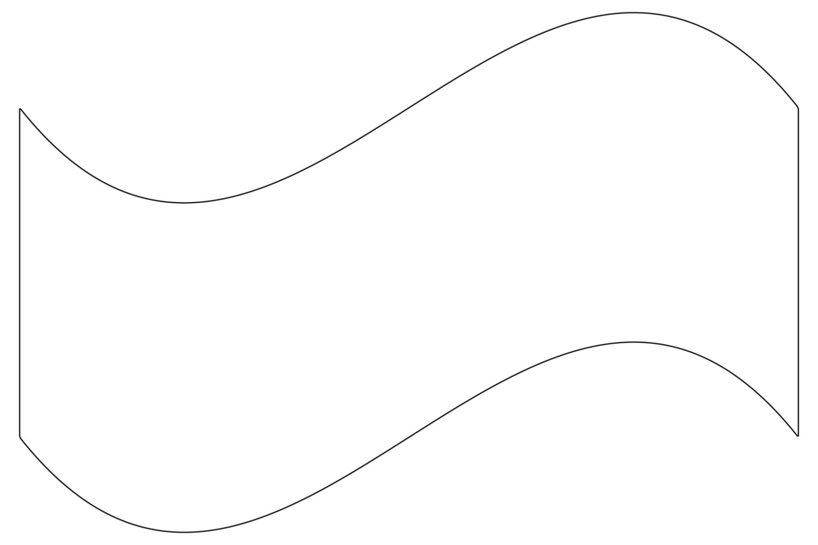
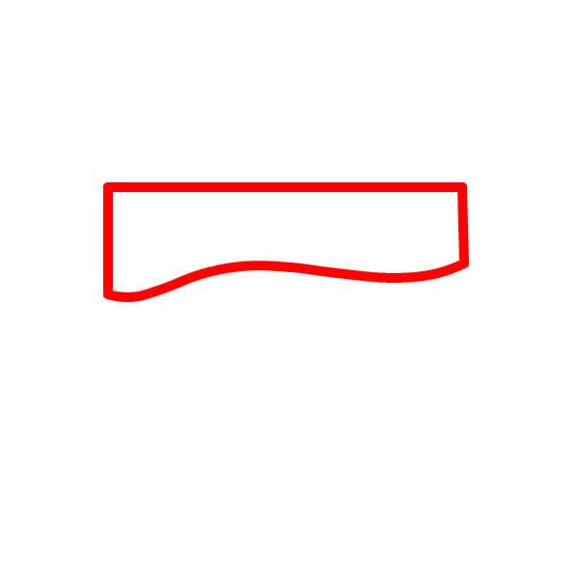
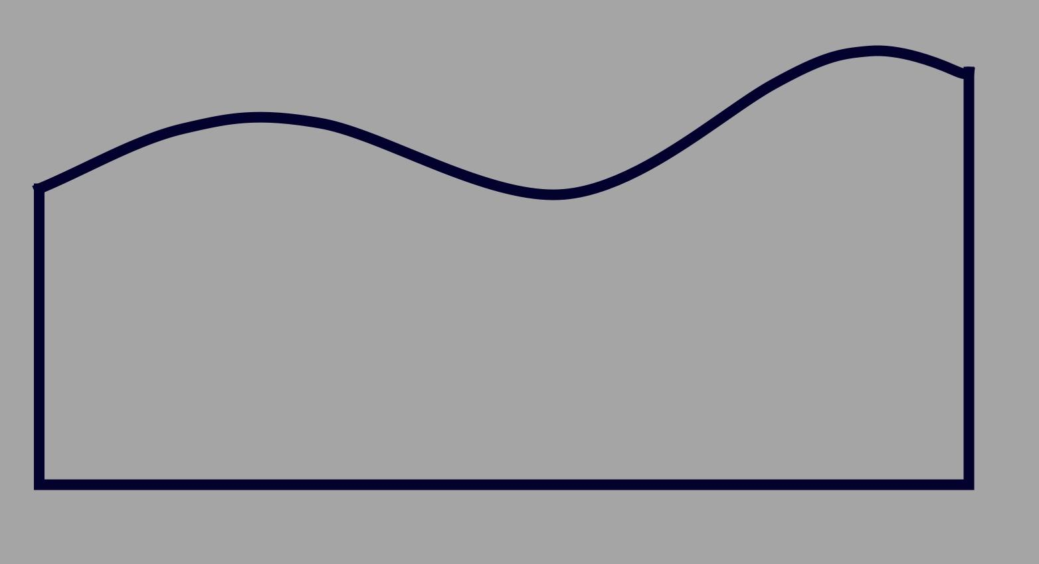
The overall path combines straight directional changes with curved portions.

10. Step-Like Rectangle–Circular Open Shape
# Source: AI Source: Provided by: [Data Path: Persons Table -> ID Column: 1, Name_En Column: Motasem Essam] -> From: [ChatGPT] on [7/25/2026]
The straight portions form a step-like pattern, with circular arcs incorporated into one or more sections.
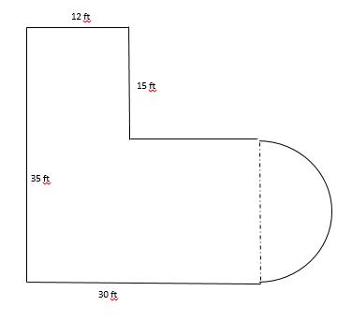
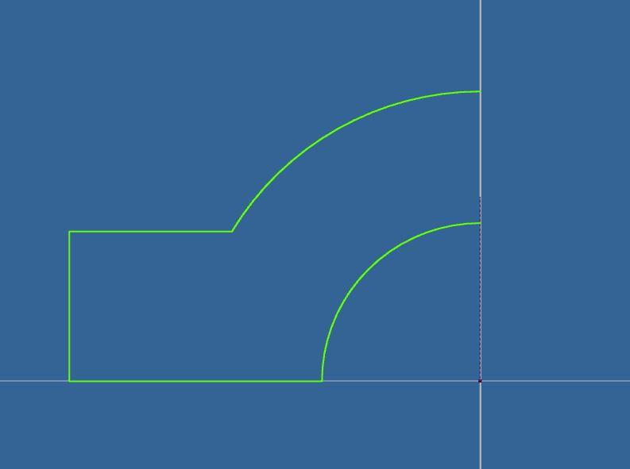
The straight sections are typically horizontal and vertical.

11. Freeform Rectangle–Circular Open Shape
# Source: AI Source: Provided by: [Data Path: Persons Table -> ID Column: 1, Name_En Column: Motasem Essam] -> From: [ChatGPT] on [7/25/2026]
A freely designed open path combining rectangular segments with circular arcs.
It does not follow one fixed standard configuration.

12. Irregular Rectangle–Circular Open Shape
# Source: AI Source: Provided by: [Data Path: Persons Table -> ID Column: 1, Name_En Column: Motasem Essam] -> From: [ChatGPT] on [7/25/2026]
An irregular combination of rectangular segments and circular arcs with varying lengths, orientations, or radii.
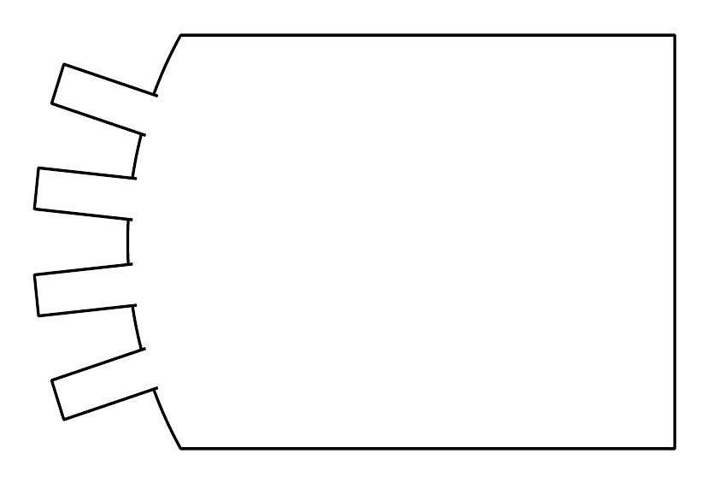
The overall shape has no regular repeating structure.

Rectangle–Circular vs. Polygon–Circular Open Shapes
# Source: AI Source: Provided by: [Data Path: Persons Table -> ID Column: 1, Name_En Column: Motasem Essam] -> From: [ChatGPT] on [7/25/2026]
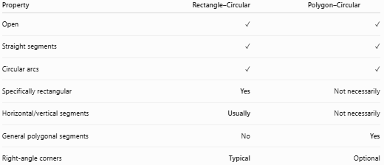
Property | Rectangle–Circular | Polygon–Circular
Open | ✓ | ✓
Straight segments | ✓ | ✓
Circular arcs | ✓ | ✓
Specifically rectangular | Yes | Not necessarily
Horizontal/vertical segments | Usually | Not necessarily
General polygonal segments | No | Yes
Right-angle corners | Typical | Optional
Main distinction
$$\boxed{\text{Rectangle–Circular}=\text{Rectangular Segments + Circular Arcs}}$$
while:
$$\boxed{\text{Polygon–Circular}=\text{General Polygonal Segments + Circular Arcs}}$$

Rectangle–Circular vs. Pure Rectilinear Open Shapes
# Source: AI Source: Provided by: [Data Path: Persons Table -> ID Column: 1, Name_En Column: Motasem Essam] -> From: [ChatGPT] on [7/25/2026]
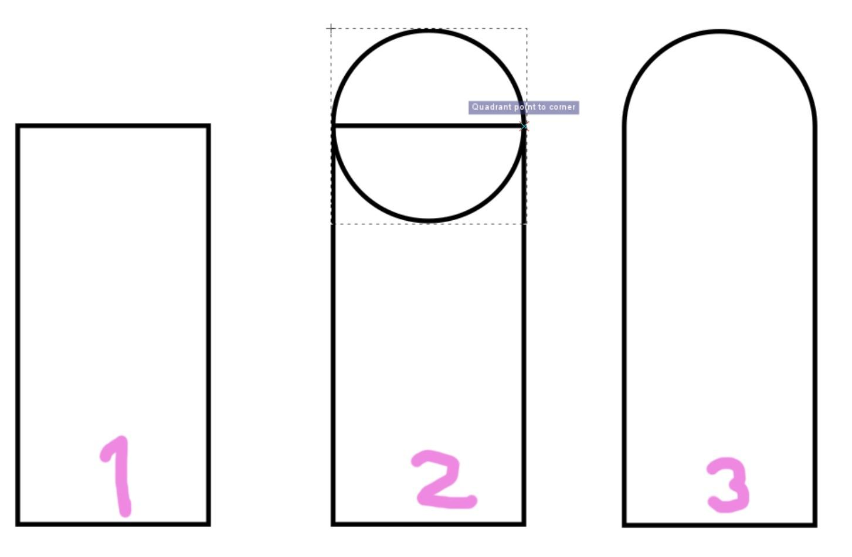
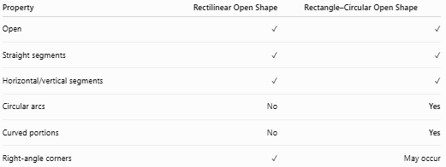
Property | Rectilinear Open Shape | Rectangle–Circular Open Shape
Open | ✓ | ✓
Straight segments | ✓ | ✓
Horizontal/vertical segments | ✓ | ✓
Circular arcs | No | Yes
Curved portions | No | Yes
Right-angle corners | ✓ | May occur

Key Points
# Source: AI Source: Provided by: [Data Path: Persons Table -> ID Column: 1, Name_En Column: Motasem Essam] -> From: [ChatGPT] on [7/25/2026]
A Rectangle–Circular Open Shape is:
$$\boxed{\text{Open}+\text{Rectangular}+\text{Circular}}$$
It:
- Has rectangular/rectilinear straight segments.
- Has at least one circular arc.
- Is not completely closed.
- Has two or more endpoints.
- May contain right-angle corners.
- May have smooth or cornered arc connections.
- Can be symmetric or asymmetric.
- Can be regular-looking, irregular, wavy, step-like, or freeform.

Conclusion
# Source: AI Source: Provided by: [Data Path: Persons Table -> ID Column: 1, Name_En Column: Motasem Essam] -> From: [ChatGPT] on [7/25/2026]
Rectangle–Circular Open Shapes are mixed open shapes that combine the horizontal and vertical structure of rectangles with the curved geometry of circular arcs. Their defining feature is the combination of rectilinear and circular components while remaining open.

